**Differential effects of habitat and fishing on coral reef grazing functions**

Drivers of macroecological patterns in herbivory on coral reefs

Drivers of coral reef herbivory varies by functional group: a macroecological approach

Macroecology of reef herbivory: bottom up and top down drivers of fish grazing functions

**Authors**

James PW Robinson1, Jamie M McDevitt-Irwin2, Jan-Claas Dajka1, Jeneen Hadj-Hammou1, Samantha Howlett1, Andrew S Hoey3, Nicholas AJ Graham1.

**Affiliations**

1. Lancaster Environment Centre, Lancaster University, Lancaster, LA1 4YQ, UK
2. Stanford University, Hopkins Marine Station, Pacific Grove, CA 93950
3. ARC Centre of Excellence for Coral Reef Studies, James Cook University, Townsville, Queensland 4811, Australia

Potential Journals:

* Global Ecology and Biogeography
* Functional Ecology (no reef herbivore papers since 2013)
* Coral Reefs

**Keywords**

functional ecology, herbivory, coral reefs, fishing, bottom-up, top-down, biodiversity, grazing, benthic

**Abstract**

**Introduction**

Herbivory is crucial to ecosystem function and community structure, playing a key role in cycling nutrients [(Metcalfe et al. 2014)](https://paperpile.com/c/Iay8oB/RhDT), regulating species diversity and productivity [(Royo et al. 2010, Prieditis et al. 2017)](https://paperpile.com/c/Iay8oB/TOHJ), and controlling habitat regime shifts [(Zimov et al. 1995; Hughes et al. 2007; Keesing and Young 2014)](https://paperpile.com/c/Iay8oB/AUW7+I1kg+WYbC). Herbivory is generally measured at small-scales that quantifies individual behaviour and population sizes, yet anthropogenic pressures are impacting ecosystem processes including herbivory across large spatial scales. Therefore, fine-scale knowledge of herbivory must be combined with macroecology to generate patterns in herbivory impacts which are relevant at large spatial scales. Such understanding is particularly relevant for coral reef ecosystems, which are facing unrelenting human pressures (including climate change, overfishing and water pollution) and where herbivory is a key ecosystem function [(Hughes et al. 2007; Ledlie et al. 2007; Cheal et al. 2010)](https://paperpile.com/c/Iay8oB/WYbC+r4IQ+EGiw).

On tropical coral reefs, top-down control of algae and promotion of calcifying coral taxa are key functions primarily performed by herbivorous fishes [(Bellwood et al. 2004)](https://paperpile.com/c/Iay8oB/jxwS). Several decades of feeding observations indicate that herbivorous fishes are comprised of three main functional roles defined by their feeding morphology and behaviours: cropping, scraping and browsing [(Bellwood and Choat 1990; Polunin et al. 1995; Green and Bellwood 2009)](https://paperpile.com/c/Iay8oB/tPmm+li2S+Abyz). Cropping species graze filamentous turf algae and promote coral settlement and growth by maintaining cropped algal states [(Arnold et al. 2010)](https://paperpile.com/c/Iay8oB/6PpY). Scraping parrotfish graze dead coral substrate to consume detritus and epilithic algal matrix (EAM), with larger species also targeting live coral and removing larger portions of hard substrate [(Bonaldo and Hoey 2014; Russ et al. 2015)](https://paperpile.com/c/Iay8oB/rorn+DxjM). Combined, these grazing functions are considered essential for providing resistance to chronic background stressors and the maintenance of coral-dominated states [(Bellwood et al. 2004)](https://paperpile.com/c/Iay8oB/jxwS).

Mature algae can proliferate in the absence of grazing pressure [(Mumby et al. 2006; Burkepile and Hay 2008)](https://paperpile.com/c/Iay8oB/EFTC+Ayr9), and correlative analyses of fished reef ecosystems have provided evidence of grazing biomass thresholds below which reefs become algae dominated [(Graham et al. 2015; Jouffray et al. 2015; Robinson et al. 2018)](https://paperpile.com/c/Iay8oB/KrVV+GLjo+hZnX). Herbivore populations are overexploited across the tropics [(Edwards et al. 2014)](https://paperpile.com/c/Iay8oB/qeW3) and, on reefs which fail to maintain herbivore biomass thresholds, grazing functions are compromised. However, fishing effects can be compounded by bottom-up influences on herbivore assemblages [(Russ et al. 2015)](https://paperpile.com/c/Iay8oB/rorn), whereby species-specific habitat associations produce spatial structuring of herbivore populations among different habitat types [(Doropoulos et al. 2013)](https://paperpile.com/c/Iay8oB/gkwk) and benthic compositions [(Gilmour et al. 2013; Heenan et al. 2016)](https://paperpile.com/c/Iay8oB/FgmJ+3WhX). Such bottom-up control of fish populations may be particularly strong when fish rely on habitat for both structure and food, such as smaller-bodied grazers (REF). Since herbivore assemblage structure is mediated by both habitat composition and fishing intensity, and our understanding of how grazing functions vary at larger scales, such as across reef regions, bottom-up processes must be disentangled from anthropogenic influences such as fishing.

Patterns in herbivore biomass are widely used to imply changes in herbivore functioning on coral reefs [(Nash et al. 2016; Robinson et al. 2018)](https://paperpile.com/c/Iay8oB/hZnX+pVwY). However, biomass data overlooks size- and species-specific differences in feeding rates and roles and so measures of grazing impacts can be improved by integrating information on feeding behaviours to estimate grazing rates [(Bellwood and Choat 1990; Bellwood et al. 2003)](https://paperpile.com/c/Iay8oB/tPmm+HM0f). Although allometric grazing ~ body size relationships [(Lokrantz et al. 2008; Nash et al. 2013)](https://paperpile.com/c/Iay8oB/QSaL+eQAv) indicate that the functional role provided by larger species is disproportionately greater [(Bonaldo and Bellwood 2008)](https://paperpile.com/c/Iay8oB/oKpw), grazing potential may also depend on community size structure. Because abundance decreases logarithmically with increasing body size (REF), an assemblage of many small-bodied fish may be functionally equivalent to an assemblage of several large-bodied individuals [(Munday and Jones 1998; Lokrantz et al. 2008)](https://paperpile.com/c/Iay8oB/Jw1X+QSaL). Shifts in size structure typically occur on inhabited reefs where size-selective exploitation removes larger individuals [(Robinson et al. 2017)](https://paperpile.com/c/Iay8oB/xcWY) and species (Taylor et al. 2014), but the link between size distribution and grazing rate is unknown. Irrespective of body size, assemblage-level grazing rates may also depend on species composition, whereby functional impact varies according to species’ relative abundance and interspecific variation in bite rates [(Hoey and Bellwood 2008)](https://paperpile.com/c/Iay8oB/7BHe). Thus, the relationship between fishing pressure and grazing function is influenced by the species composition and size structure of the herbivore assemblage, which implies that habitat- or fishing-induced shifts in biomass distributions and assemblage compositions can result in a disproportionate loss of function, thereby causing biomass ~ function relationships to become decoupled. Despite the critical role of herbivory in determining benthic responses to disturbance [(Nash et al. 2016)](https://paperpile.com/c/Iay8oB/pVwY), the direction and strength of biomass ~ function relationships under different habitat and fishing pressure remains unmeasured at large spatial scales.

Here, we combine underwater visual census (UVC) data with herbivore feeding observations across four regions in the Indo-Pacific to assess the drivers of herbivore functioning on coral reefs at a macroecological spatial scale (Fig. 1). Our large spatial scale analysis uses UVC data that was collected at reefs spanning a benthic gradient from coral to macroalgal dominance and a fishing gradient from open-access fisheries to marine protected areas (MPA) and near-pristine wilderness areas [(Graham and McClanahan 2013)](https://paperpile.com/c/Iay8oB/3Xbx). We ask the questions: 1) How does fishing pressure and benthic composition influence the functioning of two major functional feeding groups (croppers and scrapers)? 2) Does grazing function scale consistently with herbivore biomass? 3) Does the composition and size structure of herbivore communities cause grazing function to decouple from grazing biomass? We hypothesise that top-down and bottom-up influences on herbivore functioning will vary by functional feeding group, with smaller grazers controlled by bottom-up benthic variability and larger scrapers controlled by top-down fishing intensity. In addition to these drivers, grazing rates will be strongly associated with herbivore biomass (i.e. positive linear relationship between grazing function and biomass) and, because species have different feeding rates and size distributions, grazing will also be determined by the number, identity and size of grazing species.

**Methods**

*Survey methods*

Fish surveys were point counts of 7 m radius (Seychelles) or belt transects of 50 m length (Maldives, Chagos, GBR) conducted on hard-bottom reef slope habitat at 3-8 m depth. Surveys were designed to minimise diver avoidance or attracting fish. In point counts, large mobile species were censused before smaller territorial species. In belt transects, large mobile fish were surveyed in one direction for a 5 m transect width, and small site-attached species were recorded in the opposite direction for a 2 m transect width. For both survey types, all diurnal, non-cryptic (>8 cm) reef-associated fish were counted and sized to the nearest centimetre (total length, TL). TL measurements were calibrated by estimating the length of sections of PVC pipe and comparing it to their known length prior to data collection each day. All fish sizes (total length, cm) were then converted to body mass (grams) using published length ~ weight relationships [(Froese and Pauly 2018)](https://paperpile.com/c/Iay8oB/yQix), and standardised by survey area to give species-level biomass estimates that were comparable across datasets (kg ha-1). The UVC dataset included 101 herbivore species, with 11 species common to all four regions (Table S1). Although we combined two UVC methods to estimate fish biomass, point counts and belt transects give comparable biomass estimates [(Samoilys and Carlos 2000)](https://paperpile.com/c/Iay8oB/6cHo). Observation error and bias were minimised because one observer (NAJG) performed all fish surveys.

Following fish surveys, benthic habitat composition was surveyed with eight 10 m line intercept transects (Seychelles), or 50 m point intercept (benthos recorded every 50 cm) transects (Maldies, Chagos Archipelago, and Great Barrier Reef). Taxa were grouped into broad functional groups (e.g. CCA, macroalgae, turf algae) and, if they were hard corals, identified to genus level. The structural complexity of the reef was visually estimated on a six-point scale, ranging from 0 (no vertical relief) to 5 (complex habitat with caves and overhangs) [(Polunin and Roberts 1993)](https://paperpile.com/c/Iay8oB/Z09c), which correlates strongly with a range of other methods for capturing the structural complexity of coral reefs [(Wilson et al. 2007)](https://paperpile.com/c/Iay8oB/yDQB)., except for benthic surveys in Seychelles (SW). Survey methods and site descriptions for each region are described in the Supplementary Material.

*Herbivore feeding observations*

Feeding observations of Indo-Pacific herbivores provided species-level estimates on bite rates and, for scrapers, bite volumes. Surveys were conducted in the Red Sea (AH), Indonesia (AH), and GBR (AH and AGL). We only analysed feeding observations for species observed in the UVC dataset (39). For each observed fish, we estimated the average feeding rate (bites per minute). For scrapers, we also estimated the average bite scar size. We define an individuals' functional impact by its feeding intensity (bite rate). By using in situ feeding observations that track fish forays, our approach accounts for variation in feeding frequency (the timing and distance of feeding forays) [(Nash et al. 2013)](https://paperpile.com/c/Iay8oB/eQAv).

*Ecological variable processing*

Herbivore species were categorised as croppers or scrapers according to published diet observations (Froese & Pauly 2018) and observations of feeding behaviours [(Green and Bellwood 2009)](https://paperpile.com/c/Iay8oB/Abyz). Croppers were defined as species feeding primarily on the epilithial algal matrix (EAM) including detritus, turf algae, and scrapers as species feeding primarily on exposed coral substrate [(Choat et al. 2002; Howard Choat et al. 2004)](https://paperpile.com/c/Iay8oB/vIcA+n61t) (Table S1). By targeting live corals and removing larger portions of reef substrate, large ‘excavating’ scraper species also contribute to coral predation [(Doropoulos et al. 2012)](https://paperpile.com/c/Iay8oB/1ovZ) and bioerosion (Bellwood et al. 2011) but, because feeding observations did not record scar depth, we include these species in the scraper group and define scraping function as potential area grazed.

We defined grazing functions separately for each functional group, and used feeding observations to convert UVC biomass estimates into the total grazing potential of croppers and scrapers. We used a Bayesian hierarchical modelling framework that estimates species- and genera-level functional rates, which allowed us to estimate grazing rates for UVC species which were not observed in feeding surveys (63). Cropper function was quantified in terms of potential feeding intensity, measured as the total number of bites per minute and derived from a predictive model which accounted for species- and genera-specific bite rates (Eqs. 1,2)

 Eq. 1

 Eq. 2

We estimated the grazing rate of each cropper observed in UVCs, and used allometric relationships to convert bite rates into grams of carbon removed through EAM consumption [(Marshell and Mumby 2015)](https://paperpile.com/c/Iay8oB/fxNU). Following Van Rooij et al. [(Rooij et al. 1998)](https://paperpile.com/c/Iay8oB/UTVd), daily carbon intake was linked to body mass as

 Eq. 3

which we then divided by the predicted number of bites per day to produce an estimate of grams carbon consumed per minute by each cropper fish observed in UVCs. We summed estimates within each UVC survey and averaged across surveys to give site-level estimates of potential cropping function.

For scrapers, we defined the potential scraping function in terms of area of substrate removed per minute. Feeding observations provided estimates of bite rates, which we modelled as a function of body size (TL, cm) according to species- and genera-specific grazing rates, for gamma distributed errors (Eqs. 4, 5).

 Eq. 4

 Eq. 5

Scraping herbivores leave distinctive bite scars which represent the area of substrate removed in each bite. To account for potential differences in scraping action among species and across sizes, we used a second underwater feeding observation dataset of scraper bite areas. Scar area (cm2) was modelled as a function of body size (TL, cm), for Gamma distributed errors (Eqs. 6,7).

 Eq. 6

 Eq. 7

By including size (TL) as an explanatory covariate, our model accounted for scar area increasing with body size (Fig. S1a) and bite rates decreasing with body size (Fig. S1b). For each observed scraper in the UVC dataset, we estimated the expected bite rate and scar size according to its species identity and body size. Species which were not observed in feeding observations were assigned genera-level bite rates. These estimates were converted to area grazed per minute (bite rate * scar size = area grazed) (m2 minute-1 hectare-1), summed within surveys and averaged to give site-level estimates of potential scraping function.

*Statistical modelling*

We modelled variation in herbivore functioning according to gradients in benthic habitat composition, exploitation pressure, and grazing assemblage biodiversity. Explanatory covariates were derived from fish and benthic surveys. First, to account for fishing effects ranging from near-pristine Chagos reefs to heavily-exploited Seychelles reefs, we estimated total community biomass as a proxy for exploitation pressure. Fishable biomass is highly sensitive to exploitation pressure and, in the Indian Ocean, is predicted by human populations, access to markets, and fisheries management [(McClanahan et al. 2016)](https://paperpile.com/c/Iay8oB/ev5r). Reefs were also assigned a categorical fishing pressure covariate to distinguish between protected (i.e. no-take), exploited, and remote reefs. Second, benthic surveys provided site-level estimates of benthic composition. We estimated the site-level cover for four major habitat-forming groups (live hard coral, macroalgae, available substrate, and rubble), and structural complexity, by averaging across replicates at each site. To understand the range of benthic habitat types across the dataset, we categorised reefs according to their benthic regime, using a correlation-based PCA and K-means clustering [(Jouffray et al. 2015)](https://paperpile.com/c/Iay8oB/KrVV). The optimal number of clusters was found using an elbow method with k=2-15 range, and then applied to the K-means clustering. For Seychelles reefs which were surveyed in multiple years, we estimated regimes at each site by averaging cover values over time. Third, we quantified grazing assemblage diversity by measuring the total number of species observed at each reef, and grazing assemblage composition by estimating Pielou’s evenness from a community matrix of species-level biomass estimates, separately for each functional group. Richness estimates were rarefied using sample-size-based rarefaction curves, where the rarefied richness estimate was set to the lowest number of individual fish observed in the dataset [(Chao and Jost 2012; Hsieh et al. 2016)](https://paperpile.com/c/Iay8oB/VGu4+zzEn). Prior to statistical modelling, we scaled and centered all continuous covariates to a mean of zero and standard deviation of one, and converted the categorical fishing status covariate into two dummy variables (fished - protected, fished - pristine) [(Schielzeth 2010)](https://paperpile.com/c/Iay8oB/sckJ).

We used multimodel inference to assess parameter effect sizes. For each function, we fitted a global linear mixed effects model with five benthic fixed effects (hard coral, macroalgae, sand, rubble and structural complexity) and four exploitation fixed effects (fishable biomass, pristine reef, protected reef and mean size), for gamma distributed errors (). Potential covariance among reefs in the same dataset and year was modelled using nested random intercept terms where, for each observation *i* at each reef *j* in dataset *k*:

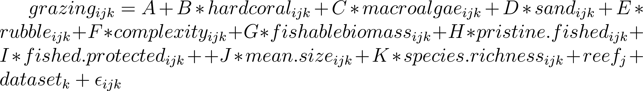 Eq. 8

From the global model, we fitted all possible subset models [(Bartoń 2013)](https://paperpile.com/c/Iay8oB/Xwtv) and assessed their support using Akaike’s Information Criterion (AIC), where the top-ranked model had the lowest AIC score [(Burnham and Anderson 2003)](https://paperpile.com/c/Iay8oB/wKrn). We visualised relative covariate effect sizes by extracting standardised t-values for all models within 7 AIC units of the top-ranked model and, for each model, rescaling t-values so that 1 is the strongest predictor in a given model, and weighing that value by the models’ AIC weight [(Cade 2015)](https://paperpile.com/c/Iay8oB/B8mT). These scaled t-values represent the relative effect size of each covariate between 0 (unimportant) and 1 (important). Next we generated model predictions to visualise the effect of each covariate with scaled t-value > 0.4, excluding remaining fixed effects and random effects and correcting predictions by each models’ AIC weight, with prediction uncertainty represented by the AIC-weighted sample variance [(Robinson et al. 2017)](https://paperpile.com/c/Iay8oB/xcWY). Our multi-model approach accounts for uncertainty in the ‘best’ fitted model when AIC scores indicate several models are equally valid [(Burnham and Anderson 2003)](https://paperpile.com/c/Iay8oB/wKrn). We avoid potential biases in model-averaged coefficient sizes by presenting effect sizes as standardised t-values, which are more informative measures of covariate importance than sums of AIC weights [(Cade 2015)](https://paperpile.com/c/Iay8oB/B8mT).

We examined the dependency of grazing function on grazing biomass, abundance and assemblage composition. For each function, we fitted a linear mixed effects model between function ~ biomass, with random intercepts of reef nested within dataset and gamma distributed errors. Deviation from 1:1 relationships (i.e. decoupling) was evaluated with R2 values, whereby high R2 indicated a tight correlation between function and biomass/abundance and low R2 indicated decoupling of function from biomass. We further investigated decoupling by fitting a global linear mixed effects model, for each observation *i* at reef (*j*) in dataset (*k*) (nested random intercepts) and gamma distributed errors:

 Eq. 9

This model allowed us to assess the influence of assemblage diversity and composition on function, while accounting for biomass and abundance effects. We fitted all subset models and weighed model support with AIC, and in this analysis, the top-ranked model was > 2 AIC units from other models, and thus covariate effect sizes and model predictions were interpreted directly from that model [(Burnham and Anderson 2003)](https://paperpile.com/c/Iay8oB/wKrn).

All data were analysed in R (R Core Team 2018), using packages *iNext* (rarefaction; [(Hsieh et al. 2016)](https://paperpile.com/c/Iay8oB/zzEn), *lme4* (linear mixed effect models; [(Bates et al. 2015)](https://paperpile.com/c/Iay8oB/1aQT), *MuMIn* (multimodel inference; [(Bartoń 2013)](https://paperpile.com/c/Iay8oB/Xwtv), *rethinking* (Bayesian models; [(McElreath 2017)](https://paperpile.com/c/Iay8oB/zbHK), and *vegan* (diversity estimates; [(Oksanen et al. 2017)](https://paperpile.com/c/Iay8oB/eqbr).

**Results**

In 132 unique reef surveys spanning four Indo-Pacific regions, herbivore assemblage richness ranged from 2 (Seychelles) to 19 species (GBR), and average biomass ranged from 24.8 (Seychelles) to 5,850 kg ha-1 (Chagos). Herbivore assemblages were dominated by scraping species, but the relative biomass of functional groups varied considerably among regions (Fig. 1C). At these reefs, we detected four benthic regimes characterised by 1) hard coral dominance, 2) macroalgal dominance, 3) high availability of bare substrate, and 4) rubble reefs (Fig. 1B). Coral dominance was the most common regime, detected at 41 reefs across all four regions, whereas bare substrate regimes were only present in Seychelles (9) and Chagos (6). Macroalgal dominance was detected on five Seychelles reefs and nine GBR reefs, while rubble reefs were only present in Seychelles (6 reefs).

After converting underwater feeding observations to potential grazing rates, benthic and fishing drivers had moderate influences on grazing, and effects were specific to grazing function. For croppers we generated bite rate predictions for 9 species which comprised 32.9% of UVC biomass, with remaining species assigned genera-specific (54.4%) or an average cropper bite rates (12.6%). Combined with biomass, these estimates were converted into algal consumption rates which ranged from 0.04 to 5.52 g ha-1 min-1 , with greatest functional impacts on GBR and Chagos reefs (Fig. S2a). Irrespective of region, algal consumption was greater in complex habitats with high substrate availability and low macroalgal densities (Fig. 3A), but hard coral or rubble cover were weak influences (Fig. 2A). Algal consumption rates were unaffected by fishing intensity, with remote, protected and fished reefs hosting similar cropping function potential (Fig. 2A). Algal consumption did increase with average cropper size, indicating that reefs with cropper assemblages dominated by larger fishes had a higher grazing potential (Fig. 2A).

Feeding data were more highly resolved for scraping herbivores, with all fishes assigned size-based bite areas, and either species- (27 of 35 species, 80.9% of UVC) or genera-specific bite rates (19.1%). Potential area scraped was greatest on GBR reefs (> 1 m2 min-1 ha-1) and lowest on Maldives reefs (< 0.3 m2 min-1 ha-1) (Figure S3b). In contrast to croppers, scraping rates increased with habitat complexity (Fig. 3B), but other benthic habitat types were weak drivers (Fig. 2B). Remote reefs had the greatest scraping rates, which were considerably lower on fished reefs than protected ones (Figs. 2B, 3C). After accounting for these coarse protection effects, scraping was only weakly associated with both fishable biomass and assemblage size structure (Fig. 2B).

Both cropping and scraping rates were strongly correlated with biomass of those groups (R2 = 0.83, Figure 4a), suggesting that the drivers of biomass variation would match tightly to the modelled drivers of cropper function (Fig. 2). Scraping function, however, was weakly associated with scraping biomass, suggesting that function has decoupled from underlying biomass levels (R2 = 0.55, Figure 4b). Unexplained variation in area scraped occurred across the biomass gradient, and in all four regions. For both groups, the addition of richness and evenness covariates to grazing ~ biomass models moderately improved predictive power (Table S3), indicating that decoupling of function from biomass was partially explained by diversity differences. These effects, however, tended to be driven by outlying reefs with uneven communities. For croppers, more even communities (i.e. more equitable biomass distribution among species) grazed greater areas, but the trend was weak (Fig. 5A). In contrast, low species evenness among scraping assemblages led to greater function rates, but again the trend was strongly influenced by outlying reefs with low evenness and high scraping rates (Fig. 5C). High richness of scraping species was also associated with greater scraping rates, but the predicted effect was weak in the context of observed scraping rates (Fig. 5B). Importantly, although diversity effects were generally outweighed by influences of abundance and biomass, diversity covariates did improve AIC scores (Table S3) and thus suggest that community composition contributed to decoupling of herbivore function from biomass.

**Discussion**

1. *Summary*

Herbivore functioning varied substantially across the Indo-Pacific in accordance with top down (i.e. fishing pressure) and bottom up (i.e. benthic habitat) drivers which were specific to each functional group. In support of our first hypothesis, we found that small-bodied croppers were primarily controlled by bottom-up influences, with function maximised in complex habitats with high substrate availability and low macroalgae cover. Conversely, for larger bodied scraping fish, function was maximised on more pristine remote reefs which have remained isolated from top-down fishing pressure. Scraping function was weakly associated with benthic habitat. Furthermore, grazing function was largely correlated with grazer biomass, which supported our second hypothesis. By accounting for this strong dependency of grazing on fish biomass, we also identified a weak positive effect of species biodiversity (richness and evenness) on grazing rates, which demonstrates that spatial variation in the number and relative abundance of species can alter grazing functions.

*2.. Cropper function is driven by bottom up benthic habitat*

Cropping rates were primarily mediated by benthic habitat type, in particular structural complexity, macroalgae cover, and substrate availability, emphasizing the strong dependence of small-bodied reef fishes on benthic composition [(Munday and Jones 1998; Wilson et al. 2010)](https://paperpile.com/c/Iay8oB/7vLY+Jw1X). These bottom-up processes exceeded top-down fishing effects, likely because croppers are small-bodied and not targeted in many reef-associated fisheries (REF). In addition, the strong relationships between benthic composition and the grazing function of small-bodied reef fish may reflect the importance of food availability, which has been shown to have stronger control on coral reef surgeonfishes than fishing pressure (Russ et al. 2018). For example, the decrease in function with increasing macroalgae is likely because turf algae are less accessible to croppers under macroalgal canopies [(Roff et al. 2015)](https://paperpile.com/c/Iay8oB/HOVM) whereas reefs with high substrate availability support turf mats which are grazed intensively (REF). An increase in available grazing substrate results in an increase in function due to the spatial constraints of individuals; so that as the amount of resources increase, so too do the fish that feed on them (Williams et al 2001). Benthic effects superseded fishing effects, implying that cropper functioning will respond more strongly to habitat disturbances, such as coral bleaching, habitat destruction, or enrichment of algal communities (REF), than to fishing. For example, disturbances which increase substrate availability for turf algal growth, such as coral mortality from heat stress, might therefore be expected to stimulate an increase in cropping function. Temporal analysis of cropping rates following habitat turnover would...

*4.. Scraper function is driven by top down fishing pressure*

Scraper function was strongly influenced by fishing pressure, decreasing at sites with high exploitation. Fishing suppressed biomass levels far below those supported at semi-pristine remote reefs such as the Chagos Archipelago, further indicating that selectivity for large-bodied scrapers has compromised scraping functions on coral reefs [(Bellwood et al. 2011)](https://paperpile.com/c/Iay8oB/9rNA). The ‘pristine effect’ superseded influences of benthic and small-scale fishing protection, suggesting that any bottom-up control of scraping assemblages on reefs leads to minimal variation in their function. Furthermore, small-scale fishing protection failed to raise herbivore biomass to pristine levels, likely because of historical fishing effects (REF), movement of fish across reserve boundaries (Graham & McClanahan 2013), and low protection compliance (REF) on many reefs, which can limit the effectiveness of small MPAs which neighbour fishing grounds.

*5A. Biomass and biodiversity increase herbivore function*

Biomass was the by far the strongest predictor of herbivory function for both functional groups, but biodiversity also had moderate effects on both cropping and scraping function. EXPLAIN EVENNESS AND RICHNESS STUFF + more on biomass

Our findings are broadly consistent with a large body of theory demonstrating the positive effect of biodiversity on ecosystem functioning (Duffy ref), but the mechanism underlying our results are unclear. For coral reefs, small-scale experiments have demonstrated that biodiversity can enhance grazing function through feeding complementarity [(Burkepile and Hay 2008, 2011)](https://paperpile.com/c/Iay8oB/Ayr9+r7a7), yet our definition of grazing function considers potential grazing rates in terms of aggregate bite rates rather than species’ diets and feeding modes. Here, therefore, diversity effects appear to extend further to promote grazing rates simply by raising the number of resident species. Richness effects can be confounded by abundance and sampling effort, though our analyses accounted for potentially spurious associations by using a rarefied richness estimate, including abundance and biomass in biodiversity models, and by capturing dataset-specific sampling correlations with a hierarchical random effects structure. Thus, our results are in agreement with a global-scale analysis of reef fish biomass patterns suggests that biodiversity promotes community biomass [(Duffy et al. 2016)](https://paperpile.com/c/Iay8oB/imyB), but extend these concepts to demonstrate that positive diversity ~ biomass relationships translate into positive diversity ~ function relationships.

*5B. Biodiversity led to decoupled biomass ~ function for scrapers*

This influence of biodiversity on function partially explained why herbivore function decoupled from herbivore biomass for the scraper functional group. Scraping functions were more highly resolved than croppers, with all fishes assigned species or genera level and size specific bite rates and areas (Lokrantz et al. 2008) and therefore our estimate of scraping function was likely to be more sensitive to changes in species diversity. In contrast, changes in cropper diversity might be obscured by the high proportion individual fishes assigned average grazing rates. We stress that biomass was by far the most important predictor of scraping function, and recovery or protection of scraping biomass will help ensure scraping processes are functionally intact on degraded coral reefs (Williams et al. 2016).

*6. Caveats*

Our predictive models did fail to account for substantial regional similarities in herbivore grazing rates, which is likely to be indicative of unmeasured processes that control fish biomass. For example, herbivore biomass variation (and thus grazing function) has been linked to differences in oceanic productivity [(Heenan et al. 2016)](https://paperpile.com/c/Iay8oB/3WhX) and disturbance regimes (REF). Fishable biomass is a coarse metric for historic fishing pressure, but selectivity for particular species and sizes may vary considerably among inhabited reefs (REF), while small-scale protection areas such as those in Seychelles are unlikely to be completely successful in preventing exploitation impacts (REF). Our definitions of grazing functions were also limited by our generalisation across species with similar functions but different feeding modes. For example, we were unable to account for differences in species morphology (REF), diet (e.g. detritivores or turf), or feeding behaviours in croppers (REF). For scrapers, we were unable to account for changes in bite depth, which likely led to underestimates of the functional impacts of the larger excavating species [(Yarlett et al. 2018)](https://paperpile.com/c/Iay8oB/1p54).

Nevertheless, the modelling framework we used to generate grazing estimates is a significant improvement on the procedure employed by previous macroscale grazing studies (e.g. [(Bellwood et al. 2011)](https://paperpile.com/c/Iay8oB/9rNA). By modelling genera- and species-specific bite rates from observations collected in several regions, we were able to leverage observational data in a hierarchical framework which predicts grazing rates of new, related species, given uncertainties in species, genera and body sizes. For example, we were able to assign bite rates to species observed in UVC but not observed in feeding surveys, with estimates that were informed by the feeding behaviour of closely related congeners. Such models could be further improved with additional feeding data on other herbivore species in different regions, and could even be developed to account for temperature controls on grazing rates [(Bruno et al. 2015)](https://paperpile.com/c/Iay8oB/ctWN) that might confound comparisons of grazing functioning across temperature regimes. Further observations of cropping behaviours would improve the resolution of grazing predictions for individual species. Similarly, other grazing functions such as browsing could be estimated in the same manner, which would greatly improve our understanding of browser functioning beyond mass-standardised bite rates (which scale directly to biomass).

*7. Extending our approach to other ecosystems - measuring functional impact with empirical data*

Additionally, it is likely that this strong relationship reflects feedback top-down control by these fishes shaping benthic community composition as also found in other habitats including, rocky intertidal [(Best et al. 2014)](https://paperpile.com/c/Iay8oB/DJq9) and terrestrial plant communities (REF).

*8. Conclusion*

*Leave till the end.*

**Acknowledgements**

[**Supplementary Material**](https://docs.google.com/document/d/1A6pmhDZbFS4G8MH2bl3PVhSFB9b_CZZxkg8GoGngsyI/edit?usp=sharing)

**Figures**

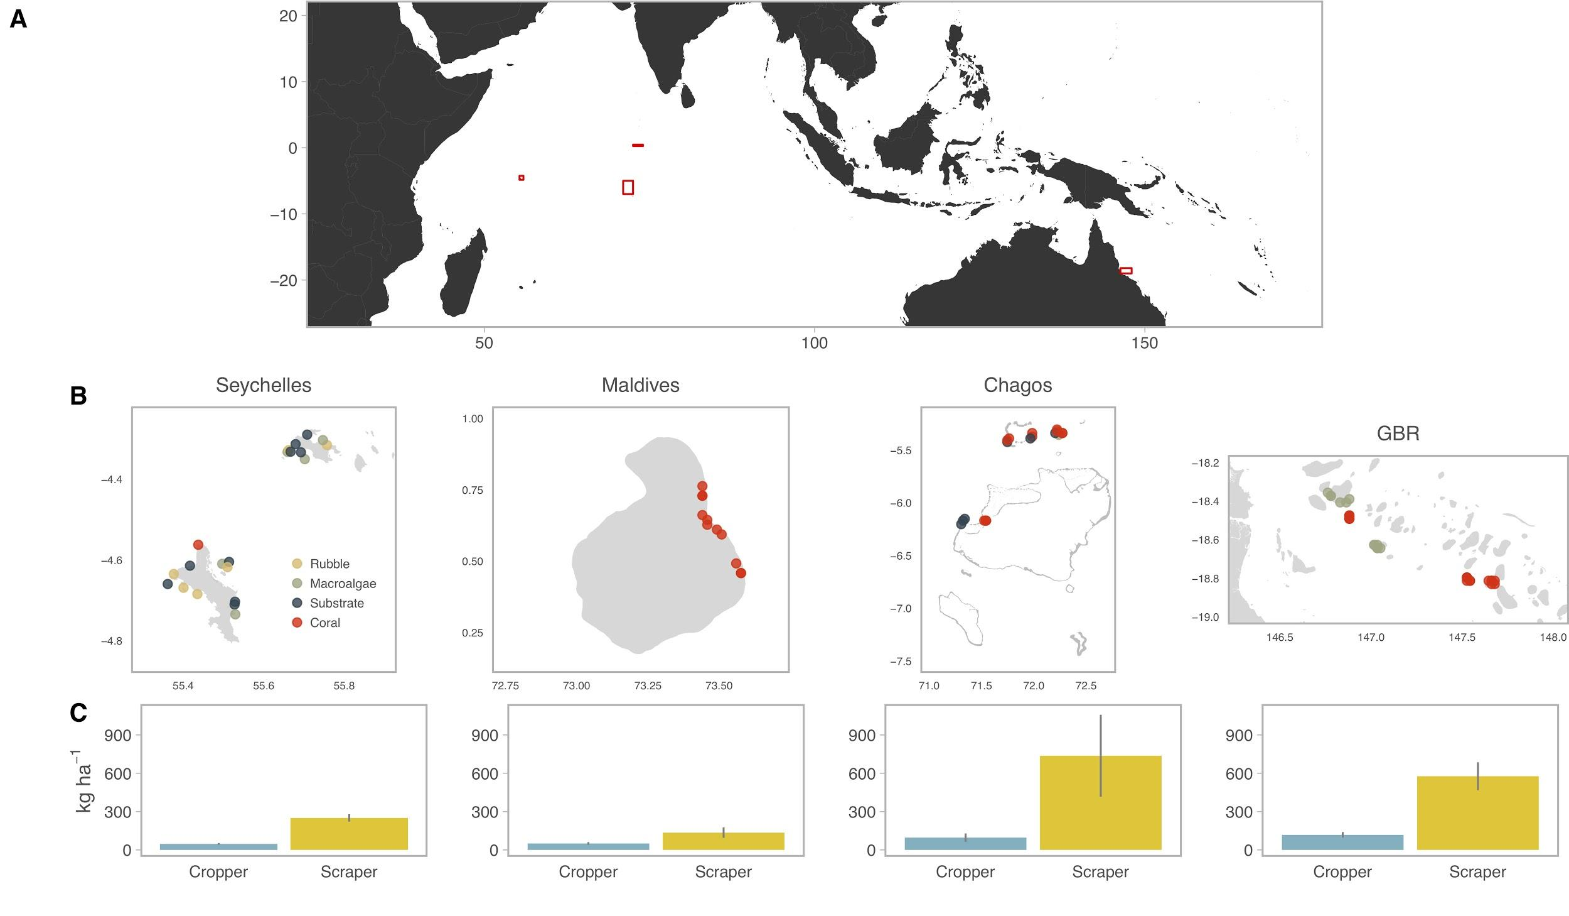

**Figure 1. Map of study sites with benthic habitat regime (B) and herbivore biomass levels (C).** Survey sites are coloured by regimes identified in k-cluster analysis (rubble = yellow, macroalgae = green, substrate = blue, coral = red), and bar plots show mean grazing biomass (± 2 standard errors).

**Figure 2. Relative effect of benthic composition and fishing pressure on herbivore functioning for croppers (A) and scrapers (B).** Bars are relative effect size ratios of each covariate for top-ranking model sets (models ≤ 7 AIC units of top-ranked model), scaled to indicate very weak (0) or very important (1) drivers of grazing rates.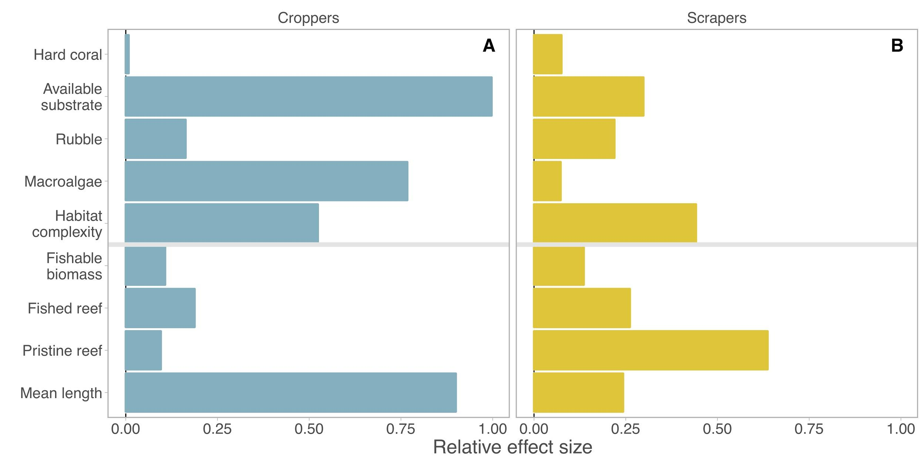

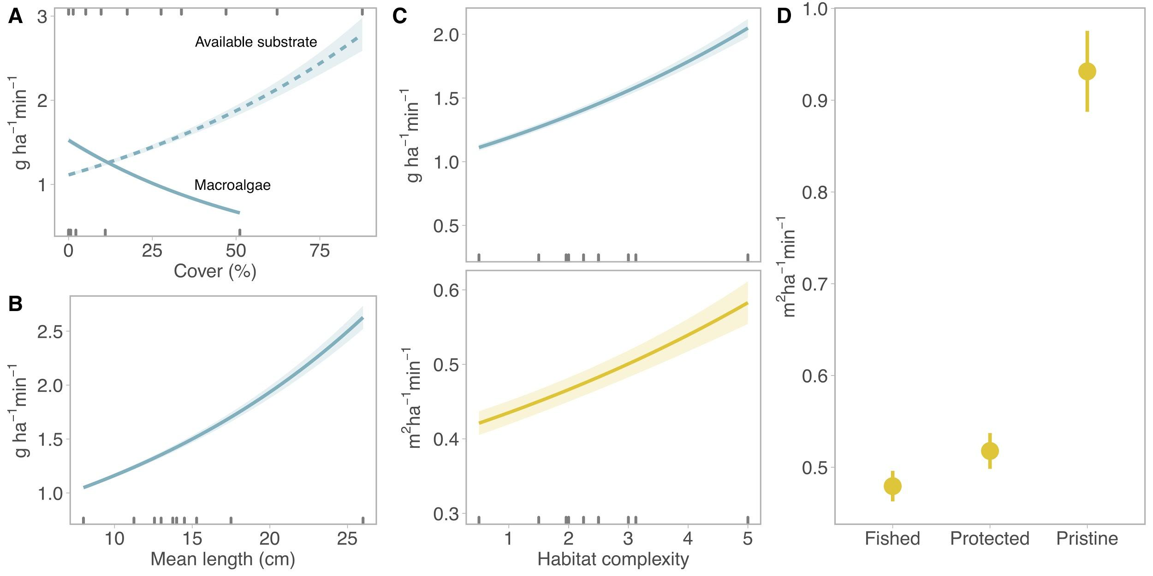

**Figure 3. Predicted effects of benthic and fishing drivers on cropper (A,B,C) and scraper (C,D) function.** Lines and points are herbivore functions as predicted by top model sets (≤ 7 AIC units from top-ranking model) holding other covariates to their means, with each model prediction weighted by its AIC weight and error represented as sample variance. All selected covariates had relative effect size ratios > 0.4 (Fig. 2). Decile rugs indicate the spread of observed data (in A, top rug is substrate and bottom rug is macroalgae).

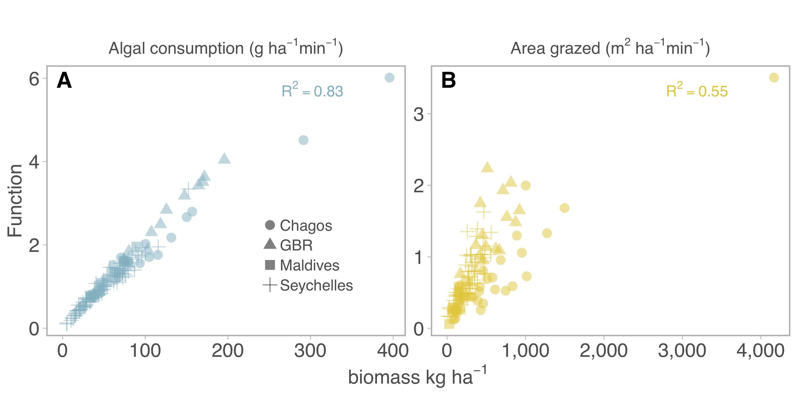

**Figure 4. Association between grazing function and grazing biomass.** Reef-level estimates of cropper algal consumption (A) and scraper area grazed (B) plotted against UVC biomass, with shapes indicating regions and labels indicating marginal R2 from a linear model of function ~ biomass.

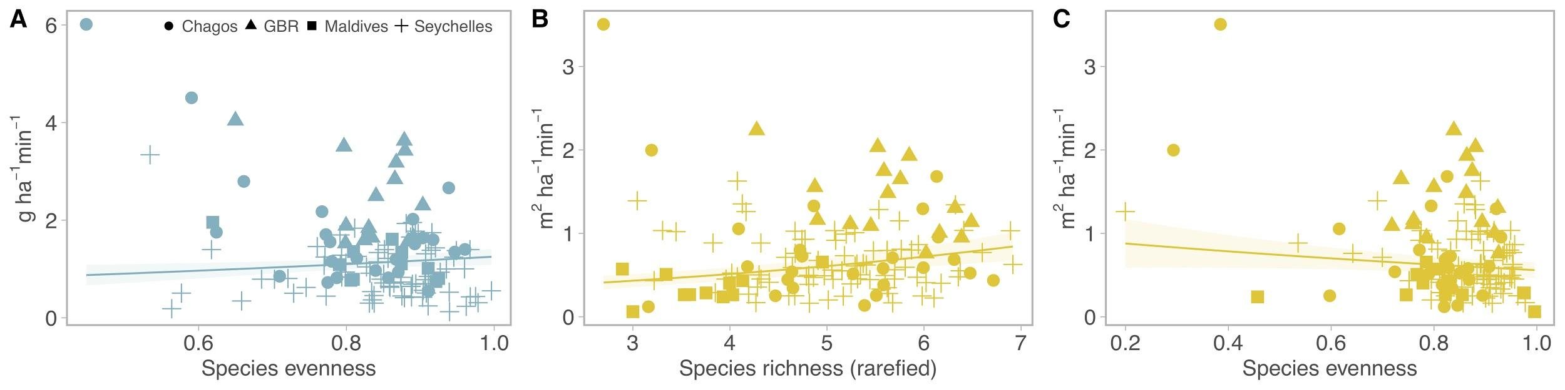

**Figure 5. Biodiversity effects on decoupling of herbivore function from herbivore biomass.** Lines are predicted effect of species evenness (A, C) and species richness (rarefied) (B) on grazing rates of croppers (blue) and scrapers (yellow), accounting for biomass and abundance effects, with two standard errors. Points are observed values, with shapes indicating reef region. Species richness (rarefied) was not retained in the top-ranking model (by AIC) for croppers (Table SX).

**References**

[Arnold SN, Steneck RS, Mumby PJ (2010) Running the gauntlet: inhibitory effects of algal turfs on the processes of coral recruitment. Mar Ecol Prog Ser 414:91–105](http://paperpile.com/b/Iay8oB/6PpY)

[Bartoń K (2013) MuMIn: multi-model inference. R package version 1:18](http://paperpile.com/b/Iay8oB/Xwtv)

[Bates D, Maechler M, Bolker B, Walker S (2015) Fitting linear mixed-effects models using lme4. J Stat Softw 67:1–48](http://paperpile.com/b/Iay8oB/1aQT)

[Bellwood DR, Choat JH (1990) A functional analysis of grazing in parrotfishes (family Scaridae): the ecological implications. Environ Biol Fishes 28:189–214](http://paperpile.com/b/Iay8oB/tPmm)

[Bellwood DR, Hoey AS, Choat JH (2003) Limited functional redundancy in high diversity systems: resilience and ecosystem function on coral reefs. Ecol Lett 6:281–285](http://paperpile.com/b/Iay8oB/HM0f)

[Bellwood DR, Hoey AS, Hughes TP (2011) Human activity selectively impacts the ecosystem roles of parrotfishes on coral reefs. Proc Biol Sci 279:1621–1629](http://paperpile.com/b/Iay8oB/9rNA)

[Bellwood DR, Hughes TP, Folke C, Nyström M (2004) Confronting the coral reef crisis. Nature 429:827–833](http://paperpile.com/b/Iay8oB/jxwS)

[Best RJ, Chaudoin AL, Bracken MES, Graham MH, Stachowicz JJ (2014) Plant–animal diversity relationships in a rocky intertidal system depend on invertebrate body size and algal cover. Ecology 95:1308–1322](http://paperpile.com/b/Iay8oB/DJq9)

[Bonaldo RM, Bellwood DR (2008) Size-dependent variation in the functional role of the parrotfish Scarus rivulatus on the Great Barrier Reef, Australia. Mar Ecol Prog Ser 360:237–244](http://paperpile.com/b/Iay8oB/oKpw)

[Bonaldo RM, Hoey AS (2014) The ecosystem roles of parrotfishes on tropical reefs. and Marine Biology: An … 52:81–132](http://paperpile.com/b/Iay8oB/DxjM)

[Bruno JF, Carr LA, O’Connor MI (2015) Exploring the role of temperature in the ocean through metabolic scaling. Ecology 96:3126–3140](http://paperpile.com/b/Iay8oB/ctWN)

[Burkepile DE, Hay ME (2008) Herbivore species richness and feeding complementarity affect community structure and function on a coral reef. Proc Natl Acad Sci U S A 105:16201–16206](http://paperpile.com/b/Iay8oB/Ayr9)

[Burkepile DE, Hay ME (2011) Feeding complementarity versus redundancy among herbivorous fishes on a Caribbean reef. Coral Reefs 30:351–362](http://paperpile.com/b/Iay8oB/r7a7)

[Burnham KP, Anderson DR (2003) Model Selection and Multimodel Inference: A Practical Information-Theoretic Approach. Springer Science & Business Media, New York](http://paperpile.com/b/Iay8oB/wKrn)

[Cade BS (2015) Model averaging and muddled multimodel inference. Ecology 96:2370–2382](http://paperpile.com/b/Iay8oB/B8mT)

[Chao A, Jost L (2012) Coverage-based rarefaction and extrapolation: standardizing samples by completeness rather than size. Ecology 93:2533–2547](http://paperpile.com/b/Iay8oB/VGu4)

[Cheal AJ, MacNeil MA, Cripps E, Emslie MJ, Jonker M, Schaffelke B, Sweatman H (2010) Coral–macroalgal phase shifts or reef resilience: links with diversity and functional roles of herbivorous fishes on the Great Barrier Reef. Coral Reefs 29:1005–1015](http://paperpile.com/b/Iay8oB/EGiw)

[Choat J, Clements K, Robbins W (2002) The trophic status of herbivorous fishes on coral reefs. Mar Biol 140:613–623](http://paperpile.com/b/Iay8oB/vIcA)

[Doropoulos C, Hyndes GA, Abecasis D, Vergés A (2013) Herbivores strongly influence algal recruitment in both coral- and algal-dominated coral reef habitats. Mar Ecol Prog Ser 486:153–164](http://paperpile.com/b/Iay8oB/gkwk)

[Doropoulos C, Ward S, Marshell A, Diaz-Pulido G, Mumby PJ (2012) Interactions among chronic and acute impacts on coral recruits: the importance of size-escape thresholds. Ecology 93:2131–2138](http://paperpile.com/b/Iay8oB/1ovZ)

[Duffy JE, Lefcheck JS, Stuart-Smith RD, Navarrete SA, Edgar GJ (2016) Biodiversity enhances reef fish biomass and resistance to climate change. Proc Natl Acad Sci U S A 113:6230–6235](http://paperpile.com/b/Iay8oB/imyB)

[Edwards CB, Friedlander AM, Green AG, Hardt MJ, Sala E, Sweatman HP, Williams ID, Zgliczynski B, Sandin SA, Smith JE (2014) Global assessment of the status of coral reef herbivorous fishes: evidence for fishing effects. Proc Biol Sci 281:20131835](http://paperpile.com/b/Iay8oB/qeW3)

[Froese R, Pauly D (2018) FishBase.](http://paperpile.com/b/Iay8oB/yQix)

[Gilmour JP, Smith LD, Heyward AJ, Baird AH, Pratchett MS (2013) Recovery of an isolated coral reef system following severe disturbance. Science 340:69–71](http://paperpile.com/b/Iay8oB/FgmJ)

[Graham NAJ, Jennings S, MacNeil MA, Mouillot D, Wilson SK (2015) Predicting climate-driven regime shifts versus rebound potential in coral reefs. Nature 518:94–97](http://paperpile.com/b/Iay8oB/GLjo)

[Graham NAJ, McClanahan TR (2013) The Last Call for Marine Wilderness? Bioscience 63:397–402](http://paperpile.com/b/Iay8oB/3Xbx)

[Green AL, Bellwood DR (2009) Monitoring functional groups of herbivorous reef fishes as indicators of coral reef resilience - A practical guide for coral reef managers in the Asia Pacific region.](http://paperpile.com/b/Iay8oB/Abyz)

[Heenan A, Hoey AS, Williams GJ, Williams ID (2016) Natural bounds on herbivorous coral reef fishes. Proc Biol Sci 283:20161716](http://paperpile.com/b/Iay8oB/3WhX)

[Hoey AS, Bellwood DR (2008) Cross-shelf variation in the role of parrotfishes on the Great Barrier Reef. Coral Reefs 27:37–47](http://paperpile.com/b/Iay8oB/7BHe)

[Howard Choat J, Robbins WD, Clements KD (2004) The trophic status of herbivorous fishes on coral reefs. Mar Biol 145:445–454](http://paperpile.com/b/Iay8oB/n61t)

[Hsieh TC, Ma KH, Chao A (2016) iNEXT: an R package for rarefaction and extrapolation of species diversity (Hill numbers). Methods Ecol Evol 7:1451–1456](http://paperpile.com/b/Iay8oB/zzEn)

[Hughes TP, Rodrigues MJ, Bellwood DR, Ceccarelli D, Hoegh-Guldberg O, McCook L, Moltschaniwskyj N, Pratchett MS, Steneck RS, Willis B (2007) Phase shifts, herbivory, and the resilience of coral reefs to climate change. Curr Biol 17:360–365](http://paperpile.com/b/Iay8oB/WYbC)

[Jouffray J-B, Nyström M, Norström AV, Williams ID, Wedding LM, Kittinger JN, Williams GJ (2015) Identifying multiple coral reef regimes and their drivers across the Hawaiian archipelago. Philos Trans R Soc Lond B Biol Sci 370:20130268](http://paperpile.com/b/Iay8oB/KrVV)

[Keesing F, Young TP (2014) Cascading Consequences of the Loss of Large Mammals in an African Savanna. Bioscience 64:487–495](http://paperpile.com/b/Iay8oB/I1kg)

[Ledlie MH, Graham NAJ, Bythell JC, Wilson SK, Jennings S, Polunin NVC, Hardcastle J (2007) Phase shifts and the role of herbivory in the resilience of coral reefs. Coral Reefs 26:641–653](http://paperpile.com/b/Iay8oB/r4IQ)

[Lokrantz J, Nyström M, Thyresson M, Johansson C (2008) The non-linear relationship between body size and function in parrotfishes. Coral Reefs 27:967–974](http://paperpile.com/b/Iay8oB/QSaL)

[Marshell A, Mumby PJ (2015) The role of surgeonfish (Acanthuridae) in maintaining algal turf biomass on coral reefs. J Exp Mar Bio Ecol 473:152–160](http://paperpile.com/b/Iay8oB/fxNU)

[McClanahan TR, Maina JM, Graham NAJ, Jones KR (2016) Modeling Reef Fish Biomass, Recovery Potential, and Management Priorities in the Western Indian Ocean. PLoS One 11:e0154585](http://paperpile.com/b/Iay8oB/ev5r)

[McElreath R (2017) Rethinking: statistical Rethinking book package. R package version 1:](http://paperpile.com/b/Iay8oB/zbHK)

[Metcalfe DB, Asner GP, Martin RE, Silva Espejo JE, Huasco WH, Farfán Amézquita FF, Carranza-Jimenez L, Galiano Cabrera DF, Baca LD, Sinca F, Huaraca Quispe LP, Taype IA, Mora LE, Dávila AR, Solórzano MM, Puma Vilca BL, Laupa Román JM, Guerra Bustios PC, Revilla NS, Tupayachi R, Girardin CAJ, Doughty CE, Malhi Y (2014) Herbivory makes major contributions to ecosystem carbon and nutrient cycling in tropical forests. Ecol Lett 17:324–332](http://paperpile.com/b/Iay8oB/RhDT)

[Mumby PJ, Dahlgren CP, Harborne AR, Kappel CV, Micheli F, Brumbaugh DR, Holmes KE, Mendes JM, Broad K, Sanchirico JN, Buch K, Box S, Stoffle RW, Gill AB (2006) Fishing, trophic cascades, and the process of grazing on coral reefs. Science 311:98–101](http://paperpile.com/b/Iay8oB/EFTC)

[Munday PL, Jones GP (1998) The Ecological Implications of Small Body Size Among Coral-Reef Fishes. Ocean Coast Manag 36:373–411](http://paperpile.com/b/Iay8oB/Jw1X)

[Nash KL, Graham NAJ, Bellwood DR (2013) Fish foraging patterns, vulnerability to fishing, and implications for the management of ecosystem function across scales. Ecol Appl 23:1632–1644](http://paperpile.com/b/Iay8oB/eQAv)

[Nash KL, Graham NAJ, Jennings S, Wilson SK, Bellwood DR (2016) Herbivore cross-scale redundancy supports response diversity and promotes coral reef resilience. J Appl Ecol 53:646–655](http://paperpile.com/b/Iay8oB/pVwY)

[Oksanen J, Guillaume Blanchet F, Friendly M, Kindt R, Legendre P, McGlinn D, Minchin PR, O’Hara RB, Simpson GL, Solymos P, Stevens MHH, Szoecs E, Wagner H (2017) vegan: Community Ecology Package. R package ersion 2.4-4:](http://paperpile.com/b/Iay8oB/eqbr)

[Polunin NVC, Harmelin-Vivien M, Galzin R (1995) Contrasts in algal food processing among five herbivorous coral-reef fishes. J Fish Biol 47:455–465](http://paperpile.com/b/Iay8oB/li2S)

[Polunin NVC, Roberts CM (1993) Greater biomass and value of target coral-reef fishes in two small Caribbean marine reserves. Marine Ecology-Progress Series 100:167–167](http://paperpile.com/b/Iay8oB/Z09c)

[Robinson JPW, Williams ID, Edwards AM, McPherson J, Yeager L, Vigliola L, Brainard RE, Baum JK (2017) Fishing degrades size structure of coral reef fish communities. Glob Chang Biol 23:1009–1022](http://paperpile.com/b/Iay8oB/xcWY)

[Robinson JPW, Williams ID, Yeager LA, McPherson JM, Clark J, Oliver TA, Baum JK (2018) Environmental conditions and herbivore biomass determine coral reef benthic community composition: implications for quantitative baselines. Coral Reefs](http://paperpile.com/b/Iay8oB/hZnX)

[Rooij JM, Videler JJ, Bruggemann JH (1998) High biomass and production but low energy transfer efficiency of Caribbean parrotfish: implications for trophic models of coral reefs. J Fish Biol 53:154–178](http://paperpile.com/b/Iay8oB/UTVd)

[Royo AA, Collins R, Adams MB, Kirschbaum C, Carson WP (2010) Pervasive interactions between ungulate browsers and disturbance regimes promote temperate forest herbaceous diversity. Ecology 91:93–105](http://paperpile.com/b/Iay8oB/TOHJ)

Prieditis, A., Howlett, S.J., Baumanis, J., Bagrade, G., Done, G., Jansons, A., Neimane, U., Ornicans, A., Stepanova, A., Smits, A. and Zunna, A., 2017. Quantification of Deer Browsing in Summer and Its Importance for Game Management in Latvia. *BALTIC FORESTRY*, *23*(2), pp.423-431.

[Russ GR, Questel S-LA, Rizzari JR, Alcala AC (2015) The parrotfish–coral relationship: refuting the ubiquity of a prevailing paradigm. Mar Biol 162:2029–2045](http://paperpile.com/b/Iay8oB/rorn)

[Samoilys MA, Carlos G (2000) Determining Methods of Underwater Visual Census for Estimating the Abundance of Coral Reef Fishes. Environ Biol Fishes 57:289–304](http://paperpile.com/b/Iay8oB/6cHo)

[Schielzeth H (2010) Simple means to improve the interpretability of regression coefficients: Interpretation of regression coefficients. Methods Ecol Evol 1:103–113](http://paperpile.com/b/Iay8oB/sckJ)

[Wilson SK, Fisher R, Pratchett MS, Graham NAJ, Dulvy NK, Turner RA, Cakacaka A, Polunin NVC (2010) Habitat degradation and fishing effects on the size structure of coral reef fish communities. Ecol Appl 20:442–451](http://paperpile.com/b/Iay8oB/7vLY)

Williams, I.D., Polunin, N.V. and Hendrick, V.J., 2001. Limits to grazing by herbivorous fishes and the impact of low coral cover on macroalgal abundance on a coral reef in Belize. *Marine Ecology Progress Series*, *222*, pp.187-196.

[Wilson SK, Graham NAJ, Polunin NVC (2007) Appraisal of visual assessments of habitat complexity and benthic composition on coral reefs. Mar Biol 151:1069–1076](http://paperpile.com/b/Iay8oB/yDQB)

[Yarlett RT, Perry CT, Wilson RW, Philpot KE (2018) Constraining species-size class variability in rates of parrotfish bioerosion on Maldivian coral reefs: implications for regional-scale bioerosion estimates. Mar Ecol Prog Ser 590:155–169](http://paperpile.com/b/Iay8oB/1p54)

[Zimov SA, Chuprynin VI, Oreshko AP, Chapin FS, Reynolds JF, Chapin MC (1995) Steppe-Tundra Transition: A Herbivore-Driven Biome Shift at the End of the Pleistocene. Am Nat 146:765–794](http://paperpile.com/b/Iay8oB/AUW7)